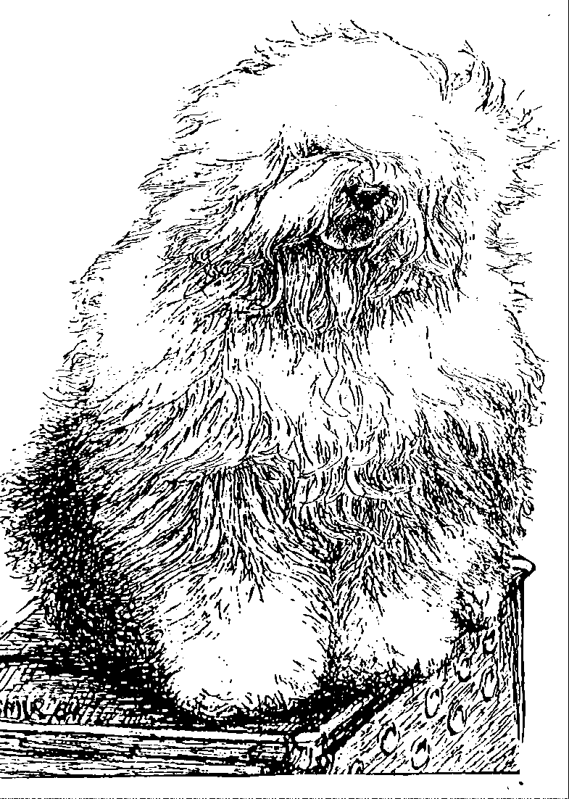
Old English Sheepdog Kennel Voorouders van:
“BRWYN” BRWYN’S Mohawk
" Nikan "
ouders | grootouders | (O)grootouders | (OO)grootouders | (OOO)grootouders
 |  |  | V. Hollyham Barny Barns | V.Rakesmoor Range Rover Of Hollyham
 |  | V. Baggybush | Of Macopa | M. Hollyhams Lady Grey
 |  | Midnight Madness | M. Baggybush | V. Jedforest Don Carlos
 | V. Lusadon Whinny Whiz |  | Bizzy Lizzy | M. True Blue Snowboots
 |  |  | V. Linconor Jazz Time | V.Barnolby Troubleshooter At Oldoak
V. Jasmist in the Tunnel |  | M. Lusadon | At Botarus | M. Kerjalee Moment In Time
Of Love |  | Over The Rainbow | M. Marlay Greensleeves | V. Darosfield Knights Templar
 |  |  | At Lusadon | M. Chysauster Betty Boop
 |  |  | V. Oldoak | V.Barnolby Troubleshooter At Oldoak
 |  | V. Oaldoak | Don’t Push Me | M. Oldoak Enchanting Memory
 |  | Strikes Back | M. Tuckles | V. Simberdale Henry Higgins
 | M. Jasmist |  | Kiss Me Kate | M. Rollingsea Katie Bay At Tuckles
 | On A Carousel |  | V. Pelajilo | V. Caioullet Waldo Pepper
 |  | M. Mellowdee | Jasper | M. Pelajilo Cassandra
 |  | Mistletoe | M. Olrons Pride and Joy | V. Pockethall Playboy Of Brinkley
 |  |  | Of Mellowdee | M.Pelajilo Bellina
 |  |  | V. Barnolby Troubleshouter | V. Weatherproof Of Barnolby
 |  | V. Souvenir | At Oldoak | M. Barnolby Wedding Bells
 | V. Saphir | Van Kehr Fully Maid | M. Silver Mystery's | V. Sparkle Square's Carte Blache
 | Kehr Fully Maid |  | Josjes Prime Time | M. Silver Mystery's Hoyden Hazel
 |  | M. Paddy Paddingtong | V. Sparkle Square's | V. Jolly Joggler's Star Light
M. Brwyn’s Own Heaven |  | Is Kehr Fully Maid | Carte Blanche | M. Barking Bear's Dorenthy Delightful
 |  |  | M. Trademark's | V. Barking Bear's Evergren my Beatle
 |  |  | Sparkle Square Sophie | M. Blueville Ain’t she Cute
 |  | V. Shawlea the | V. Bonny's Chum | V. Arlils Gentleman Of The Ring
 |  | Devils Disciple | At Simberdale | M. Dican Secret Of Simberdale
 |  |  | M. Shawlea | V. Ch. DebdalePersonality Og Gojolega
 | M. Cathy’s Clown Heaven |  | Princess Pippin | M. Oak Apple Off my Eye
 | On Earth | M. Cathy's Clown | V. Blueville's | V. Shapod Special Sirprise
 |  | Criminal Beauty | Robin Hood | M. Secret Hope Blue Badge of Honour
 |  |  | M. Missy | V. Reeuwijk's Desmond
 |  |  |  | M. Woodlane's Melody

