Old English Sheepdog Kennel Voorouders van:
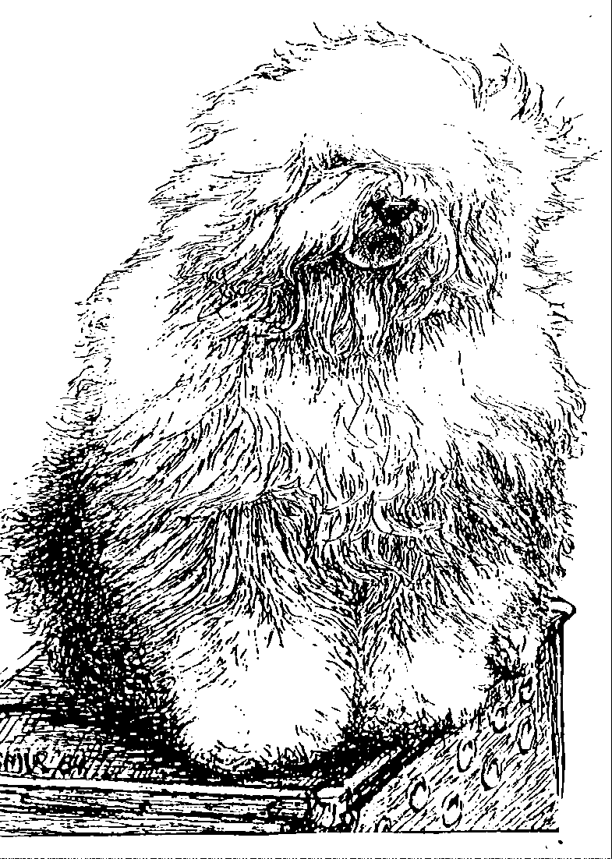
“BRWYN” BRWYN’S OLD FASHIONED GIRL
“ Kylie ”

ouders | grootouders | (O)grootouders | (OO)grootouders | (OOO)grootouders
 |  |  | V. Arlils Gentleman | V. Tynycoed Caradog Ap Tegwch
 |  | V. Bonny’s | Of The Ring | M. Arlils Gay Lady
 |  | Chum at Simberdale | M. Dican Secret | V. Simberdale Henry Higgins
 | V. Shawlea |  | Of Simberdale | M. Bella Donna Of Dican
 | The Devils Disciple |  | V. Ch.Debdale Personality | V. Ch. Ginnsdale Stargazer Blue of Barnolby
 |  | M. Shawlea | Og Gojolega | M. Tinkerbell Sally of Debdale
 |  | Princess Pippin | M. Oak Apple | V. Tywysog Hiberth
V. Cathy’s Clown |  |  | Off my Eye | M. Burni of Close
Call to Glorie |  |  | V. Shapod Special | V. Ch. Tumbletop Trademark of Denimblue
 |  | V. Blueville’s | Surprise | M. Bluewaldar Nilma of the Hills
 |  | Robin Hood | M. Secret Hope | V. Tynycoed Dynamic
 | M. Cathy’s Clown |  | Blue Badge of Honour | M. Fernville Secret Hope
 | Criminal Beauty |  | V. Reeuwijk’s | V. Ellenglaze Ladies Choice
 |  | M. Missy | Desmond | M. Fezziwig Silver Lining
 |  |  | M. Woodlane’s | V. Duke Choice Rolima
 |  |  | Melody | M. Woodlane’s Endless-Lass
 |  |  | V. Pockethall Shoemaker | V. Pockethall New Shoes
 |  | V. Brackenhome | of Oakfarm | M. Pockethall Silver Shoes
 |  | Shadow of Oakfarm | M. Barnolby Shaggy Shoes | V. Ginnsdale Stargazer Blue of Barnolby
 | V. Oakfarm |  | of Brackenhome | M. Sincerity of Barnolby
 | Odysee |  | V. Pockethall Shoemaker | V. Pockethall New Shoes
 |  | M. Oleanna | of Oakfarm | M. Pockethall Silver Shoes
 |  | of Oakfarm | M. Woodnymph | V. Wildahar Forester
M. Cathy’s Clown |  |  | Sweet Charity | M. Wildahar Sofia
My Flair Lady |  |  | V. Ellenglaze | V. Misselwaithe Squire Dickon
 |  | V. Reeuwijk’s | Ladies Choice | M. Ellenglaze Fleur Forsythe
 |  | Desmond | M. Fezziwig | V. Fezziwig Hoodwink
 | M. Missy |  | Silver Lining | M. Fezziwig Homeward Bound
 |  |  | V. Rolima | V. Sleepy Hollow’s Diplomat
 |  | M. Woodlane’s | Duke Choice | M. Salceri’s Melody
 |  | Melody | M. Woodlane’s | V. Reeuwijk’s Desmond
 |  |  | Endless Lass | M. Woodlane’s California Dream

