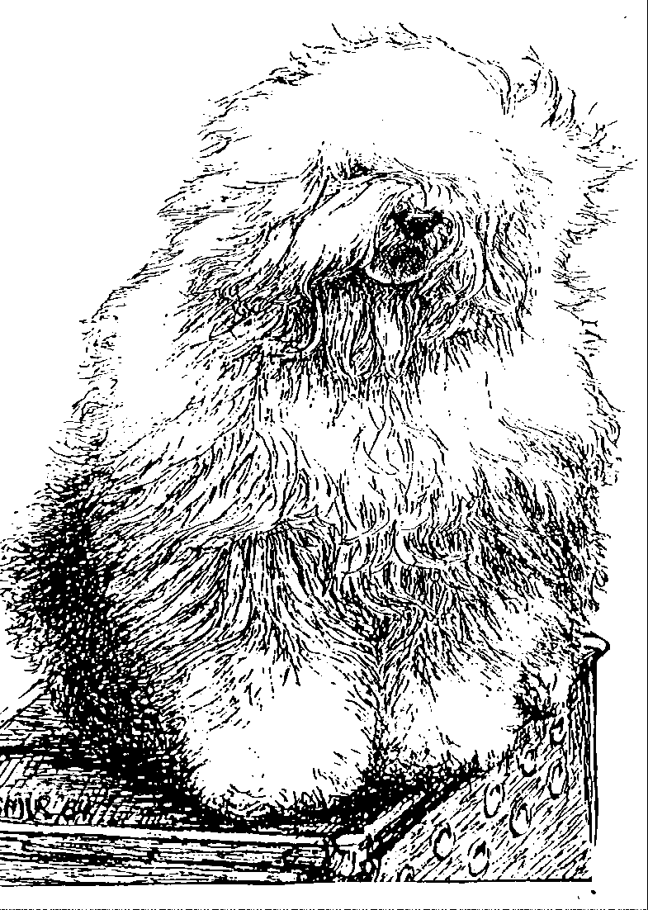
Old English Sheepdog Kennel Voorouders van:
“BRWYN” BRWYN’S MOVE HEAVEN AND EARTH
" Duppie"
ouders | grootouders | (O)grootouders | (OO)grootouders | (OOO)grootouders
 |  |  | V. Weatherproof | V. Barnolby Lord Shavley
 |  | V. Barnolby Troubleshouter | Of Barnolby | M. Janmay of Kenstaff
 |  | At Oldoak | M. Barnolby | V. Ginnsdale Stargazer Blue of Barnolby
 | V. Souvenir |  | Wedding Bells | M. Barnolby White Bear
 | Van Kehr Fully Maid |  | V. Sparkle Square's | V. Jolly Joggler's Star Light
 |  | M. Silver Mystery's | Carte Blanche | M. Barking Bear's Dorenthy Delightful
 |  | Josjes Prime Time | M. Silver Mystery's | V. Barking's Bear's Dacy Belle
V. Saphir |  |  | Hoyden Hazel | M. Vigilat's Unique Surprise
Kehr Fully Maid |  |  | V. Jolly Joggler's | V. Pockethall Prince William
 |  | V. Sparkle Square's | Star Light | M. Donnibobs Wot A Picture
 |  | Carte Blanche | M. Barking Bear's | V. Shaggy Bear's Sugar Foot Stomp
 | M. Paddy Paddingtong |  | Dorenthy Delightful | M. Amble Gait's Arrabelle Blue
 | Is Kehr Fully Maid |  | V. Barking Bear's | V. Pockethall Prince William
 |  | M. Trademark's | Evergreen my Beatle | M. Amble Gait's Arrabelle Blue
 |  | Sparkle Square Sophie | M. Blueville | V. Shapod Special Surprise
 |  |  | Ain't she Cute | M. Baucott Blue Delft
 |  |  | V. Arlils Gentleman | V. Tynycoed Caradog Ap Tegwch
 |  | V. Bonny's Chum | Of The Ring | M. Arlils Gay Lady
 |  | At Simberdale | M. Dican Secret | V. Simberdale Henry Higgins
 | V. Shawlea the |  | Of Simberdale | M. Bella Donna Of Dican
 | Devils Disciple |  | V. Ch. DebdalePersonality | V. Ch. Ginnsdale Stargazer Blue of Barnolby
 |  | M. Shawlea | Og Gojolega | M. Tinkerbel Sally of Debdale
 |  | Princess Pippin | M. Oak Apple | V. Tywysog Hiberth
M. Cathy's Clown |  |  | Off my Eye | M. Burni of Close
Heaven on Earth |  |  | V. Shapod Special | V. Ch. Tumbletop Trademark of Denimblue
 |  | V. Blueville's | Surprise | M. Bluewaldar Nilma of the Hills
 |  | Robin Hood | M. Secret Hope | V. Tynycoed Dynamic
 | M. Cathy's Clown |  | Blue Badge of Honour | M. Fernville Secret Hope
 | Criminal Beauty |  | V. Reeuwijk's Desmond | V. Ellenglaze Ladies Choice
 |  | M. Missy |  | M. Fezziwig Silver Lining
 |  |  | M. Woodlane's | V. Duke Choice Rolima
 |  |  | Melody | M. Woodlane's Endless-Lass

