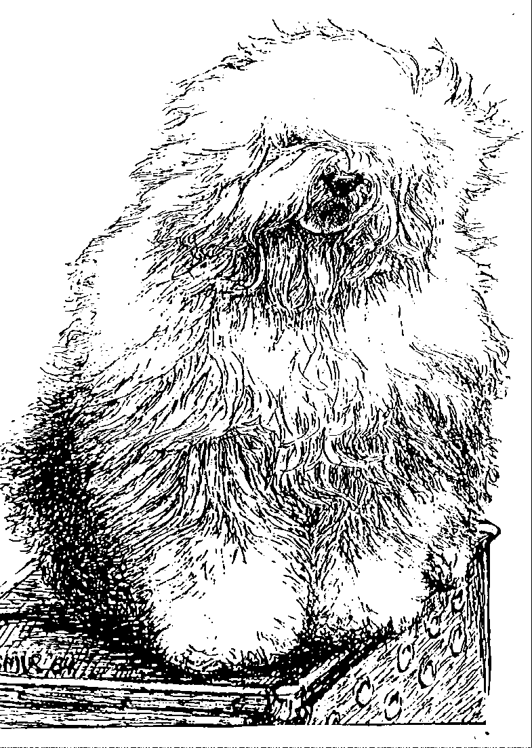
ld English Sheepdog Kennel Voorouders van:
“BRWYN” BRWYN’S Welkom
" Doortje"
ouders | grootouders | (O)grootouders | (OO)grootouders | (OOO)grootouders
 |  |  | V. Barnolby Troubleshouter | V. Weatherproof Of Barnolby
 |  | V. Souvenir | At Oldoak | M. Barnolby Wedding Bells
 | V. Saphir | Van Kehr Fully Maid | M. Silver Mystery's | V. Sparkle Square's Carte Blache
 | Kehr Fully Maid |  | Josjes Prime Time | M. Silver Mystery's Hoyden Hazel
 |  | M. Paddy Paddingtong | V. Sparkle Square's | V. Jolly Joggler's Star Light
V. Brwyn’s Made Kehrfull |  | Is Kehr Fully Maid | Carte Blanche | M. Barking Bear's Dorenthy Delightful
In Heaven |  |  | M. Trademark's | V. Barking Bear's Evergren my Beatle
 |  |  | Sparkle Square Sophie | M. Blueville Ain’t she Cute
 |  | V. Shawlea the | V. Bonny's Chum | V. Arlils Gentleman Of The Ring
 |  | Devils Disciple | At Simberdale | M. Dican Secret Of Simberdale
 |  |  | M. Shawlea | V. Ch. DebdalePersonality Og Gojolega
 | M. Cathy’s Clown Heaven |  | Princess Pippin | M. Oak Apple Off my Eye
 | On Earth | M. Cathy's Clown | V. Blueville's | V. Shapod Special Sirprise
 |  | Criminal Beauty | Robin Hood | M. Secret Hope Blue Badge of Honour
 |  |  | M. Missy | V. Reeuwijk's Desmond
 |  |  |  | M. Woodlane's Melody
 |  |  | V. Bonny’s | V. Arlils Gentleman Of The Ring
 |  | V. Shawlea | Chum at Simberdale | M. Dican Secret Of Somberdale
 | V. Cathy’s Clown | The Devils Disciple | M. Shawlea | V. Ch.Debdale Personality Og Gojolega
 | Call to Glorie |  | Princess Pippin | M. Oak Apple Off my Eye
 |  |  | V. Blueville’s | V. Shapod Special Surprise
M. Brwyn’s Old Fashioned |  | M. Cathy’s Clown | Robin Hood | M. Secret Hope Blue Badge of Honour
Girl |  | Criminal Beauty | M. Missy | V. Reeuwijk’s Desmond
 |  |  |  | M. Woodlane’s Melody
 |  |  | V. Brackenhome | V. Pockethall Shoemaker of Oakfarm
 |  | V. Oakfarm | Shadow of Oakfarm | M. Barnolby Shaggy Shoes of Brackenhome
 | M. Cathy’s Clown | Odysee | M. Oleanna | V. Pockethall Shoemaker of Oakfarm
 | My Flair Lady |  | of Oakfarm | M. Woodnymph Sweet Charity
 |  |  | V. Reeuwijk’s | V. Ellenglaze Ladies Choice
 |  | M. Missy | Desmond | M. Fezziwig Silver Lining
 |  |  | M. Woodlane’s | V. Rolima Duke Choice
 |  |  | Melody | M. Woodlane’s Endless Lass

