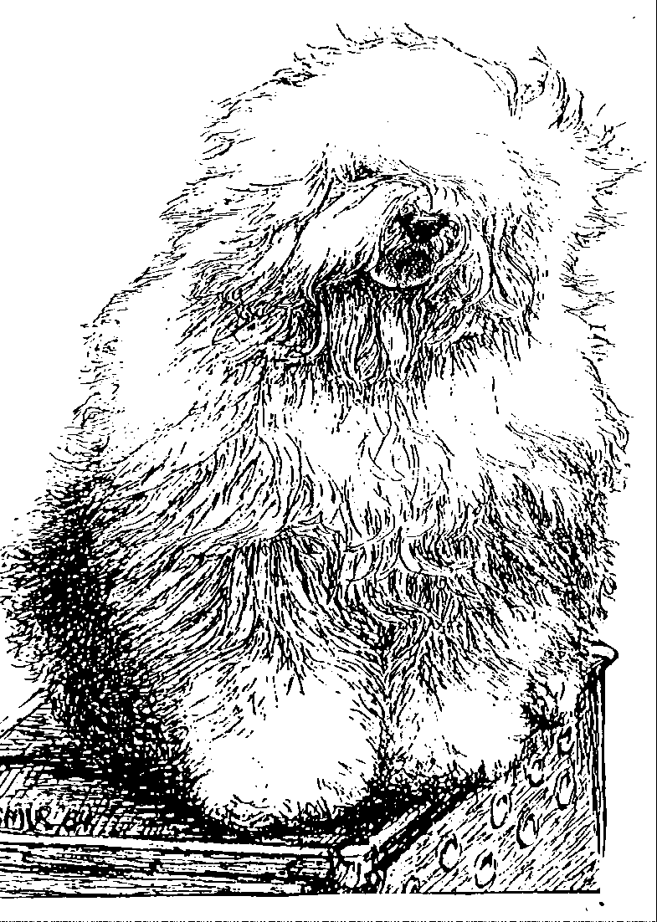
Old English Sheepdog Kennel Voorouders van:
“BRWYN” BRWYN’S BEAR ON SNOWSH’OES
" Cartouche "
ouders | grootouders | (O)grootouders | (OO)grootouders | (OOO)grootouders
 |  |  | V. Tynycoed Caradog | V. Jedforest DonCarlos
 |  |  | ap Tegwch | M. Tynycoed Un Prydferth
 | V. Lamedazottel | V. Greyfell | M. Trushayp Effervescence | V. Bartines Most Happy Fella of Jenards
 | Good Gossip | Storm Warning | at Greyfell | M. Sweet Charlotte Of Trushayp
 |  |  | V. Lohengrin | V. Herkules aus Dem Elbe-Urstrumtal
 |  | M. Zottel’s Miss Marple | aus dem Elbe-Urstromtal | M. Appelsnut aus Dem Elbe-Urstrumtal
V. Our Snowboot Bear |  | of Lameda | M. Reeuwijk’s Filmstar | V. Reeuwijk’s Dew Fantasy
Of Fools Paradise |  |  | in Silver | M. Reeuwijk’s Care For Beauty
 |  |  | V. Pockethall | V. Trushayp Eckythump of Jenards
 |  | V. Zottel Free Mason | I’Mashootoo | M. Pockethall Silver Charm
 |  | at Ebonyivory | M. Zottel’s Miss Marple | V. Lohengrin aus dem Elbe Urstrumtal
 | M. Ala Carte |  | of Lameda | M. Reeuwijk’s Filmstar In Silver
 | a.d. Elbe-Urstromtal | M. Liebe ist | V. Zottel’s Magic Touch | V. Lohengrin aus dem Elbe- Urstromtal
 |  | aus dem Elbe-Urstomtal |  | M. Reeuwijk’s Filmstar In Silver
 |  |  | M. Danabba’s Abicht | V. Rembrandt aus dem Elbe-Urstromtal
 |  |  |  | M. Osterei aus dem Elbe- Urstromtal
 |  |  | V. Barnolby Troubleshouter | V. Weatherproof Of Barnolby
 |  | V. Souvenir | at Oldoak | M. Barnolby Wedding Bells
 | V. Saphir | van Kehr Fully Maid | M. Silver Mystery's | V. Sparkle Square's Carte Blanche
 | Kehr Fully Maid |  | Josjes Prime Time | M. Silver Mystery's Hoyden Hazel
M. Brwyn’s Own Heaven |  |  | V. Sparkle Square's | V. Jolly Joggler's Star Light
 |  | M. Paddy Paddingtong | Carte Blanche | M. Barking Bear's Dorenthy Delightful
 |  | is Kehr Fully Maid | M. Trademark's | V. Barking Bear's Evergreen my Beatle
 |  |  | Sparkle Square Sophie | M. Blueville Ain't she Cute
 |  |  | V. Bonny's Chum | V. Arlils Gentleman Of The Ring
 |  | V. Shawlea the | at Simberdale | M. Dican Secret Of Simberdale
 | M. Cathy's Clown | Devils Disciple | M. Shawlea | V. Ch. DebdalePersonality Og Gojolega
 | Heaven on Earth |  | Princess Pippin | M. Oak Apple Off my Eye
 |  |  | V. Blueville's | V. Shapod Special Surprise
 |  | M. Cathy's Clown | Robin Hood | M. Secret Hope Blue Badge of Honour
 |  | Criminal Beauty | M. Missy | V. Reeuwijk's Desmond
 |  |  |  | M. Woodlane's Melody

