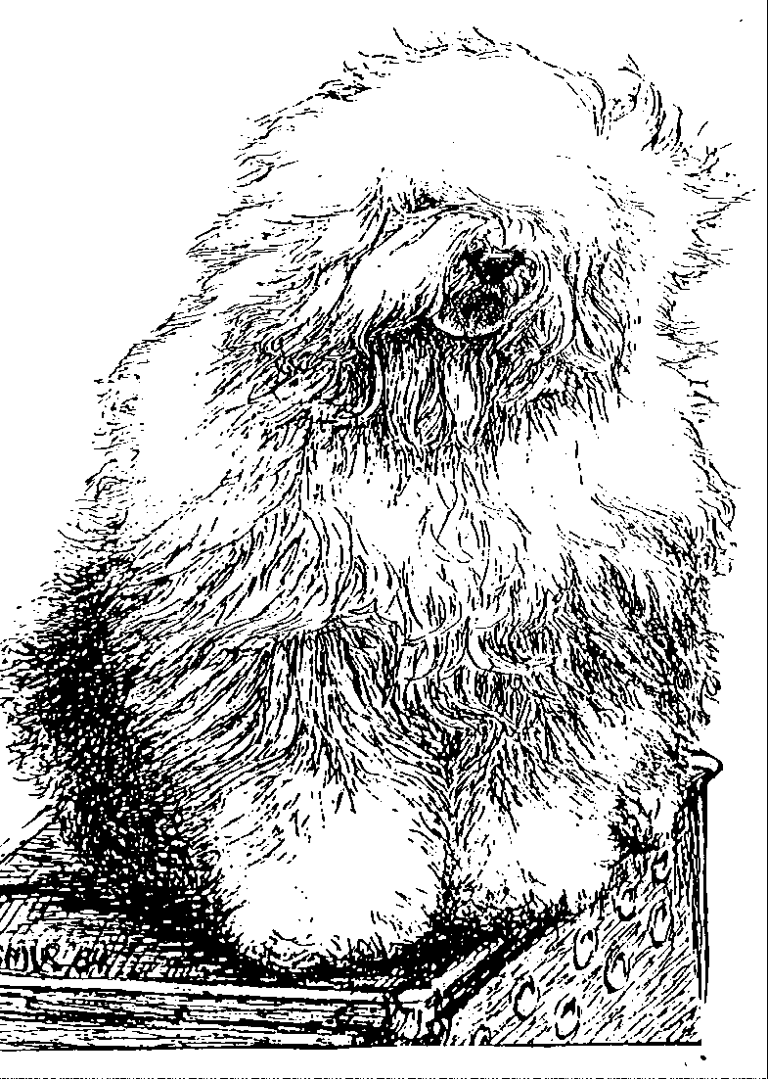
Old English Sheepdog Kennel Voorouders van:
“BRWYN” BRWYN’S JULTOMTEN
" Thaïsa "

ouders | grootouders | (O)grootouders | (OO)grootouders | (OOO)grootouders
 |  |  | V. Ch. Bobbington | V. Ch. Amblegait Amboyna of Stourvale
 |  | V. Ch. Babiton Take Two | Latin Lover | M. Ch. Oakfarm Beth of Bobbington
 |  |  | M. Ch. Bobbington | V. Ch. Oakfarm Oberon
 | V. Dizzny's Artfull |  | Geneva | M. Ballabruk Tzuki
 | Dodger |  | V. Ch. Bahlamb's | V. Moptop's Lambluv Master Plan
V. Vigilat’s Dear Tomte |  | M. Ch. Dizzny's Modesty | Barnyard Baron | M. Ch. Bahlamb's Barnyard Beauty
Tummetodd |  | Blaise | M. Ch. Dizzny's | V. Ch. Unnesta Halligang
 |  |  | Hope and Glory | M. Ch. Bahlamb's Bedazzling Bear
 |  |  | V. Ch. Vigilat's | V. Ch. Barking's Bear Davy Belle
 |  | V. Ch. Vigilat's Quick | Different Yip | M. Vigilat's Yoline
 |  | Dustin | M. Vigilat's | V. Ch. Stoffel's Balou
 | M. Latina Lavigi |  | Kissable Lady | M. Ch. Vigilat's Wicked Lady
 |  |  | V. Sugar Bear from | V. Ch. Woodlane's Elliott
 |  | M. Lizzie Frizzie | Beautyfull Highland | M. Scarlett O'Hara of Pelajilo
 |  |  | M. Vigilat's | V. Ch. Stoffel's Balou
 |  |  | Latin Pluche | M. Vigilat’s Drop Shot
 |  |  | V. Greyfell | V. Tynycoed Caradog ap Tegwch
 |  | V Lamedazottel | Storm Warning | M. Trushayp Effervescence at Greyfell
 | V Our Snowboot Bear | Good Gossip | M. Zottel’s Miss Marple | V. Lohengrin a/d/ Elbe Urstromtal
 | Of Fools Paradise |  | Of Lemada | M. Reeuwijk’s Filmstar in Silver
 |  | M. Ala Carte | V Zottel Free mason | V. Pockethall I’Mashootoo.
M. Brwyn’s Bear |  | Aus dem Elbe- Urstromtal | At Ebonyivory | M. Zottel’s Miss marple of Lameda
Snowsh’oes |  |  | M. Liebe ist | V. Zottel’s magic Touch
 |  |  | aus dem Elbe Urstromtal | M. Danabba’s Abicht
 |  | V. . Saphir | V . Souvenir | V. Barnolby Troubleshouter at Oldoak
 |  | Kehr Fully Maid | Van Kehr Fully Maid | M. Silver Mystery's Josjes Prime Time
 |  |  | M. Paddy Paddingtong | V. . Sparkle Square's Carte Blanche
 | M Brwyn’s Own Heaven |  | Is Kehr Fully Maid | M. Trademark's Sparkle Square Sophie
 |  | M. . Cathy’s Clown Heaven | V Shawlea the | V. Bonny's Chum At Simberdale
 |  | On Earth | Devils Disciple | M. Shawlea Princess Pippin
 |  |  | M. Cathy's Clown | V. Blueville's Robin Hood
 |  |  | Criminal Beauty | M. Missy

