Old English Sheepdog Kennel Voorouders van:
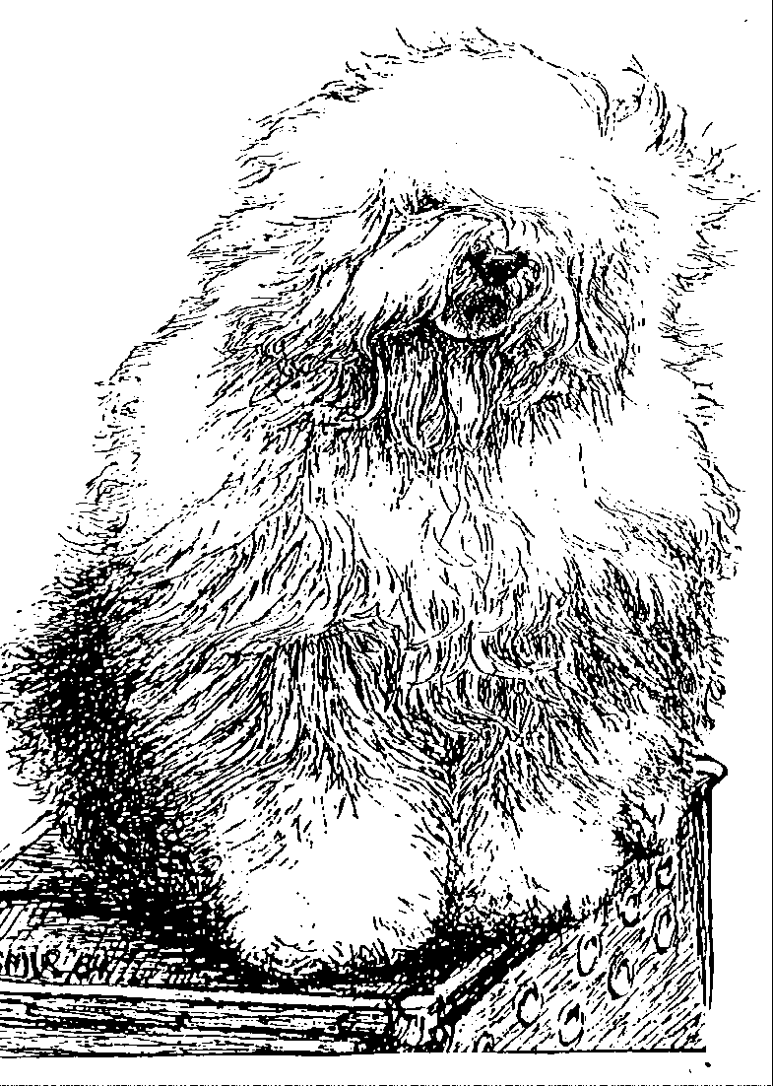
“BRWYN” BRWYN’S PAPERINO
“ KEESJE ”
ouders | grootouders | (O)grootouders | (OO)grootouders | (OOO)grootouders
 |  |  | V. Ch. Sparkle Square’s China | V. Ch.Jolly Joggler’s Star Light
 |  | V. Ch. Santa Barbara’s | Blue | M. Barking Bear’s Dorently Delightful
 | V. Ch. Karlo von den | Ambrosius | M. Happy Panda’s | V. Ch. Vigilat’s Woody Allen
 | Blue Zottel’s |  | Dolly parton | M. Ch. Umsobesser a/d Elbe Urstomtal
 |  |  | V. Ch. Stoffel’s Bertram | V. Ch. Vigilat’s Woody Allen
 |  | M. Daisy von den |  | M. Britta vom Tatzelwurm
 |  | Blue Zottel’s | M. Bine von den | V. Ch. Flint von den Blue Bobs
V. Ch. Brwyn’s |  |  | Blue Zottel’s | M. Nina aus dem Hundewald
Friends Forever |  |  | V. Shawlea The Devils | V. Bonny’s Chum of Simberdale
 |  | V. Ch. Cathy’s Clown | Disciple | M. Shawlea Princess Pippin
 |  | Call to Glorie | M. Cathy’s Clown | V. Blueville’s Robin Hood
 | M. Ch. Brwyn’s Lamborghini |  | Criminal Beauty | M. Missy
 | Miura |  | V. Saphir Kehr Fully | V. Souvenir van Kehr Fully maid
 |  | M. Ch. Brwyn’s Who Wants | Maid | M Paddy Paddington is Kehr Fully Maid
 |  | To Live Forever | M. Kadootje van | V. Barnolby Troubleshooter At Oldoak
 |  |  | Kehr Fully Maid | M. Silver Mystery’s Josje’s Prime Time
 |  |  | V. Shawlea The Devils | V. Bonny’s Chum At Simberdale
 |  | V. Cathy’s Clown | Disciple | M. Shawlea Princess Pippin
 |  | Call to Glorie | M. Cathy’s Clown | V. Blueville’s Robin Hood
 | V. Ch. Brwyn’s Bohemian |  | Criminal Beauty | M. Missy
 | Rhapsody |  | V. Oalfarm Odysee | V. Brackenhome Shadow of Oakfarm
 |  | M. Cathy’s Clown |  | M. Oleanne Of Oakfarm
 |  | My Flair Lady | M. Missy | V. Reeuwijk’s Desmond
M. Brwyn’s Knocking on |  |  |  | M. Woodlane’s Melody
Heavens Door |  |  | V. Ch. Souvenir | V. Barnolby Troubleshouter At Oldoak
 |  | V. Saphir Kehr Fully maid | Van Kehr Fully Maid | M. Silver Mistery’s Josjes Prime Time
 |  |  | M. Paddy Paddington | V. Sparkle Square’s Carte Blanche
 | M. Brwyn’s Move Heaven |  | Is Kehr Fully Maid | M. Trademark’s Sparkle Square Sophie
 | And Earth |  | V. Shawlea the Devils | V Bonny’s Chum At Simberdale.
 |  | M. Cathy’s Clown Heaven | Descipel | M. Shawlea Princess Pippin
 |  | On Earth | M. Ch. Cathy’s Clown | V. Blueville’s Robin Hood
 |  |  | Criminal Beauty | M. Missy

