Old English Sheepdog Kennel Voorouders van:
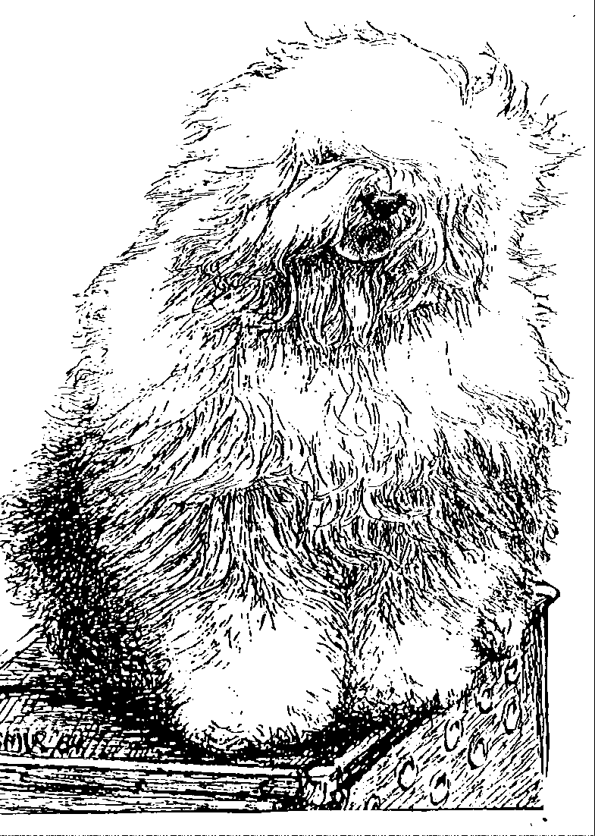
“BRWYN” BRWYN’S MISS SMILLA
“ Smilla ”
ouders | grootouders | (O)grootouders | (OO)grootouders | (OOO)grootouders
 |  |  | V. Int. Ch. Sparkle | V. Ch. Jolly Joggler's Star Light
 |  | V. Ch. Santa Barbara's | Square's China Blue | M. Barking Bear's Dorently Delightful
 |  | Ambrosius | M. Happy Panda's | V. Int. Ch. Vigilat's Woody Allen
 | V. Int Ch. Karlo |  | Dolly parton | M. Ch.Umsobesser a/d Elbe Urstromtal
 | von den Blue Zottel's |  | V. Int. Ch. Stoffel's | V. Int. Ch. Vigilat's Woody Allen
 |  | M. Daisy von den | Bertram | M. Britta vom Tatzelwurm
V. Ch. Brwyn’s |  | Blue Zottel's | M. Bine von den | V. Ch. Flint von den Blue Bobs
Friends Forever |  |  | Blue Zottel's | M. Nina aus dem Hundewald
 |  |  | V. Shawlea | V. Bonny's Chum of Simberdale
 |  | V. Cathy's Clown | The Devils Disciple | M. Shawlea Princess Pippin
 | M. Int.Ch. Brwyn’s | Call to Glorie | M. Ch. Cathy's Clown | V. Blueville's Robin Hood
 | Lamborghini Miura |  | Criminal Beauty | M. Missy
 |  |  | V. Ch. Saphir | V. Souvenir van Kehr Fully Maid
 |  | M. Ch. Brwyn's | Kehr Fully Maid | M. Paddy Paddington is Kehr Fully Maid
 |  | Who Wants to Live | M. Kadootje | V. Barnolby Troubleshooter At Oldoak
 |  | Forever | van Kehr Fully Maid | M. Silver Mystery's Josje's Prime Time
 |  |  | V. Greyfell | V. Tynycoed Caradog ap Tegwch
 |  | V. Lamedazottel | Storm Warning | M. Trushayp Effervescence at Greyfell
 | V.Ch. Our Snowboot Bear | Good Gossip | M. Zottel’s Miss Marple | V. Lohengrin a/d Elbe-Urstromtal
 | Of Fools Paradise |  | of Lameda | M. Reeuwijk’s Filmstar in Silver
 |  |  | V. Zottel Free Mason | V. Pockethall I’Mashootoo
 |  | M. Ala Carte | at Ebonyivory | M. Zottel’s Miss Marple of Lameda
M. Brwyn’s Bear |  | a.d. Elbe-Urstromtal | M. Liebe ist | V. Zottel’s Magic Touch
On Snowsh’oes |  |  | aus dem Elbe-Urstomtal | M. Danabba’s Abicht
 |  |  | V. Ch. Souvenir | V.Barnolby Troubleshouter at oldoak
 |  | V. Saphir | van Kehr Fully Maid | M. Silver Mystery's Josjes Prime Time
 |  | Kehr Fully Maid | M. Paddy Paddington | V. Sparkle Square's Carte Blanche
 | M. Ch. Brwyn’s Own Heaven |  | is Kehr Fully Maid | M. Trademark's Sparkle Square Sophie
 |  |  | V. Shawlea the | V. Bonny's Chum at Simberdale
 |  | M. Cathy's Clown | Devils Disciple | M. Shawlea Princess Pippin
 |  | Heaven on Earth | M. Ch. Cathy's Clown | V. Blueville's Robin Hood
 |  |  | Criminal Beauty | M. Missy

