Old English Sheepdog Kennel Voorouders van:
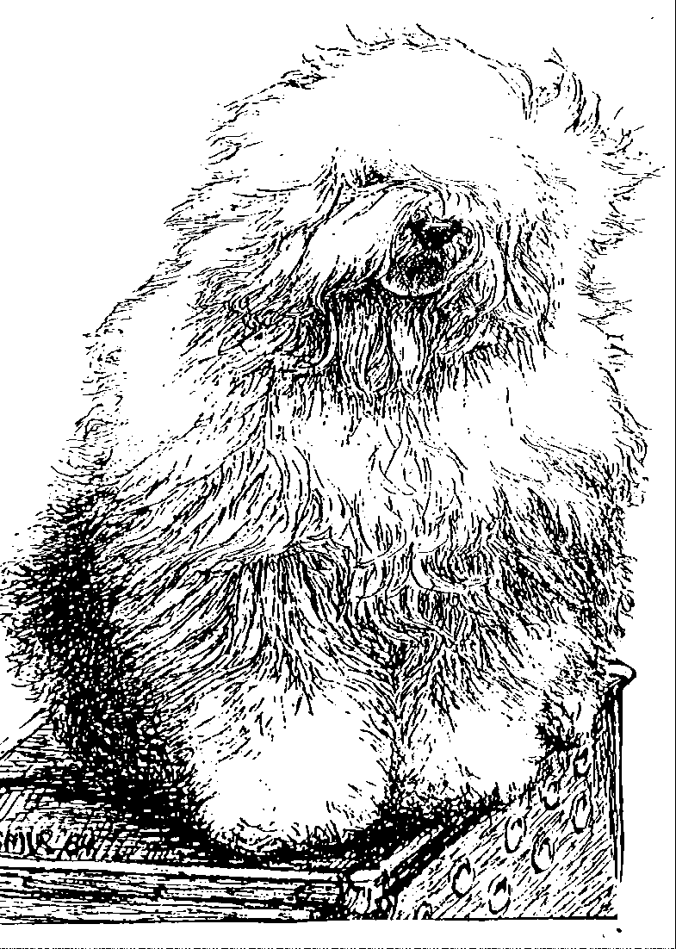
“BRWYN” BRWYN’S LAMBORGHINI MIURA
“Shannon”
ouders | grootouders | (O)grootouders | (OO)grootouders | (OOO)grootouders
 |  |  | V. Arlil’s Gentleman | V. Tynycoed Caradog Ap Tegwch
 |  | V. Bonny’s Chum | Of The Ring | M. Arlil’s Gay Lady
 | V. Shawlea | Of Simberdale | M. Dican Secret | V. Simberdale Henry Higgins
 | The Devils Disciple |  | Of Simberdale | M. Bella Donna Of Dican
 |  |  | V. CH. Debdale Personality | V. Ginnsdale Stargazer Blue of Barnolby
 |  | M. Shawlea | Og Gojolega | M. Tinkerbell Sally of Debdale
 |  | Princess Pippin | M. Oak Apple | V. Tywysog Hiberth
V. Cathy’s Clown |  |  | Off my Eye | M.Burni of Close
Call to Glorie |  |  | V. Shapod Special | V. Tumbletop Trademark of Denimblue
 |  | V. Blueville’s | Surprise | M. Bluewaldar Nilma of the Hills
 |  | Robin Hood | M. Secret Hope | V. Tynycoed Dynamic
 | M. Cathy’s Clown |  | Blue Badge of Honour | M. Fernville Secret Hope
 | Criminal Beauty |  | V. Reeuwijk’s | V. Ellenglaze Ladies Choice
 |  | M. Missy | Desmond | M. Fezziwig Silver Lining
 |  |  | M. Woodlane’s | V. Duke Choice Rolima
 |  |  | Melody | M. Woodlane’s Endless-Lass
 |  |  | V. Barnolby Troubleshooter | V. Weatherproof of Barnolby
 |  | V. Souvenir | At Oldoak | M. Barnolby Wedding Wedding Bells
 |  | Van Kehr Fully Maid | M. Silver Mistery’s | V. Sparkle Square’s Carte Blanche
 | V. Saphir |  | Josje’s Prime Time | M. Silver Mystery’s Hoyden Hazel
 | Kehr Fully Maid |  | V. Sparkle Square’s | V. Jolly Joggler’s Star Light
 |  | M. Paddy Paddington | Carte Blanche | M. Barking Bear’s Dorenthy Delightful
 |  | Is Kehr Fully Maid | M. Trademark’s | V. Barking Bear’s Evergreen my Beatle
M. Brwyn’s Who |  |  | Sparkle Square Sophie | M. Blueville Ain’t she Cute
Wants to Live Forever |  |  | V. Weatherproof | V. Barnolby Lord Shavley
 |  | V. Barnolby Troubleshooter | Of Barnolby | M. Janmay of Kenstaff
 |  | At Oldoak | M. Barnolby | V. Ginnsdale Stargazer Blue of Barnolby
 | M. Kadootje |  | Wedding Bells | M. Barnolby White Bear
 | Van Kehr Fully Maid |  | V. Sparkle Square’s | V. Jolly Joggler’s Star Light
 |  | M. Silver Mystery’s | Carte Blanche | M. Barking Bear’s Dorenthy Delightful
 |  | Josje’s Prime Time | M. Silver Mystery’s | V. Barking Bear’s Davy Bell
 |  |  | Hoyden’s Hazel | M. Vigilat’s Unique Surprise

