Old English Sheepdog Kennel Voorouders van:
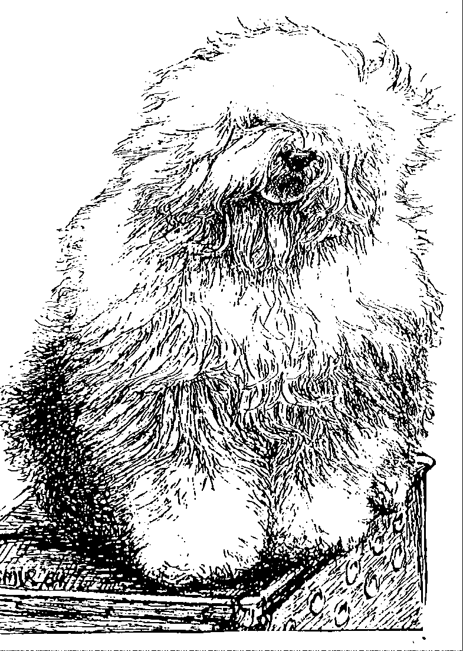
“BRWYN” Brwyn’s Knocking on Heavens Door
Senna
ouders | grootouders | (O)grootouders | (OO)grootouders | (OOO)grootouders
 |  |  | V. Bonny’s Chum of | V. Arlils Gentleman of the Ring
 |  | V. Shawlea | Simberdale | M. Dican Secret of Simberdale
 | V. Cathy’s Clown Call to | The Devils Disciple | M. Shawlea Princess Pippin | V. Debdale Personality of Gojolega
 | Glorie |  |  | M. Oal Apple of my Eye
 |  |  | V. Blueville’s Robin Hood | V. Shapod Special Surprise
 |  | M. Ch. Cathy’s Clown |  | M. Secret Hope Blue Badge of Honour
 |  | Criminal Beauty | M. Missy | V. Reeswijk’s Desmond
V. Ch. Brwyn’s |  |  |  | M. Woodlane’s Melody
Bohemian Rhapsody |  |  | V. Brackenhome | V. Pockethall Shoemaker
 |  | V. Oakfarm Odysee | Shadow of Oakfarm | M. Barnolby Shaggy Shoes of Brackenhome
 |  |  | M. Oleanne | V. Pockethall Shoemaker of Oakfarm
 | M. Ch. Cathy’s Clown |  | Of Oakfarm | M.Woodnymph Sweet Charity
 | My Flair Lady |  | V.Reeuwijk’s Desmond | V. Ellenglaze Ladies Choice
 |  | M. Missy |  | M. Fezziwig Silver Lining
 |  |  | M. Woodlane’s | V. Barnolby Troubleshouter At Oldoak
 |  |  | Melody | M. Silver Mystery’s Josje’s Primte time
 |  |  | V. Barnolby Troubleshouter | V. Weatherproof of Barnolby
 |  | V. Souvenir | At Oldoak | M. Dican Secret of Simberdale
 |  | Van kehr Fully Maid | M. Silver Mystery’s | V. Sparkle Square’s Carte Blanche
 | V. Saphir Kerhr Fully Maid |  | Josjes Prime Time | M. Silver Mystery’s Hoyden Hazel
 |  |  | V. Sparkle Square’s | V. Jolly Joggler’s Star Light
 |  | M. Paddy Paddington | Carte Blanche | M. Secret Hope Blue Badge of Honour
 |  | Ids Kehr Fully Maid | M. Trademark’s Sparkle | V. Reeuwijk's Desmond
M. Brwyn’s |  |  | Square Sophie | M. Woodlane's Melody
Move Heaven and Earth |  |  | V. Bonny’s Chum | V. Arlils Gentleman Of The Ring
 |  | V. Shawlea the Devils | At Simberdale | M. Dican Secret Of Simberdale
 |  | Descipel | M. Shawlea | V. DepdalePersonality Og Gojolrgs
 | M. Cathy’s Clown |  | Princess Pippin | M. Oak Apple Off my Eye
 | Heaven on Earth |  | V. Blueville’s | V. Shapod Special Surprise
 |  | M. Cathy’s Clown | Robin Hood | M. Secret Hope Blue Badge of Honour
 |  | Criminal Beauty | M. Missy | V. Reeuwijk’s Desmond
 |  |  |  | M. Woodlene’s Melody

