Old English Sheepdog Kennel Voorouders van:
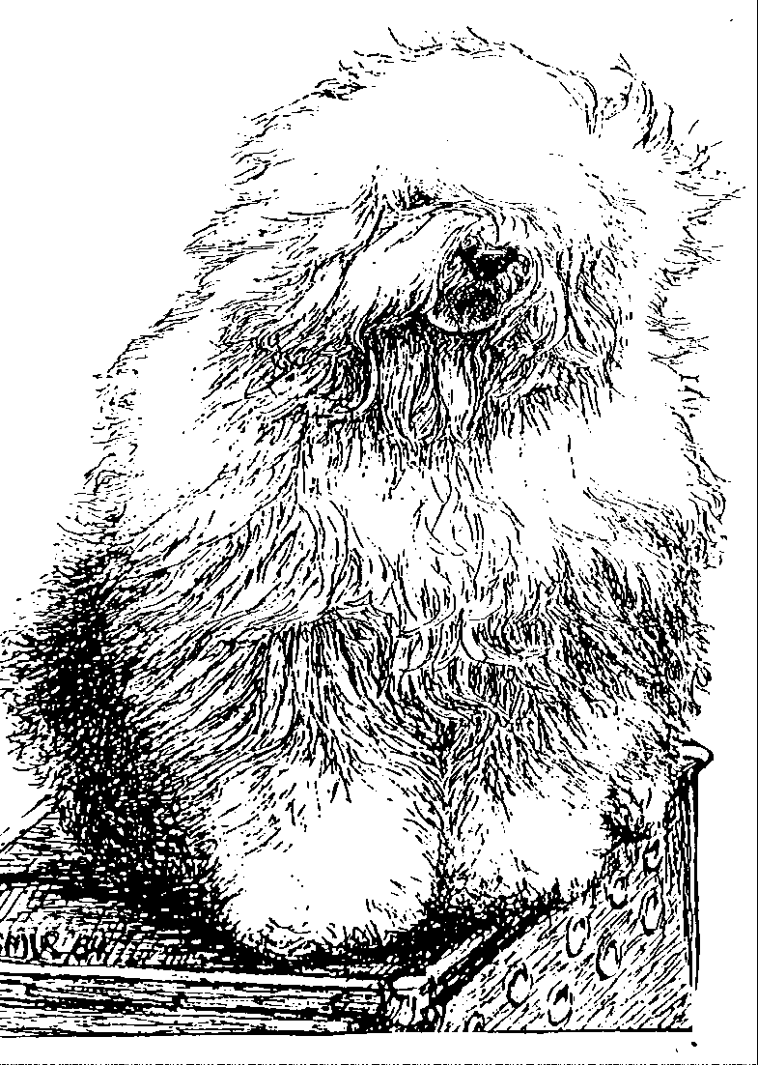
“BRWYN” BRWYN’S HEAVENLY HUGS TEDDY BEAR
“ Gina ”
ouders | grootouders | (O)grootouders | (OO)grootouders | (OOO)grootouders
 |  |  | V. Ch. Jolly Joggler's | V. Ch. Pockethall Prince William
 |  | V. Int. Ch. Sparkle | Star Light | M. Donnibobs Wot a Picture
 | V. Ch. Santa Barbara's | Square's China Blue | M. Barking Bear's | V. Shaggy Bear's Sugar Foot Stomp
 | Ambrosius |  | Dorently Delightful | M. Amble Gait's Arabella Blue
 |  |  | V. Int. Ch. Vigilat's | V. Int. Ch. Button Nose Amadeus
 |  | M. Happy Panda's | Woody Allen | M. Vigilat's Pretty Thing
 |  | Dolly parton | M. Int. Ch. Umsobesser | V. Chris aus dem Elbe Urstromtal
V. Ch. Karlo von den Blue |  |  | aus dem Elbe Urstromtal | M. Ch. Hot Dog a/d Elbe Urstromtal
Zottel's |  |  | V. Int. Ch. Vigilat's | V. Int. Ch. Button Nose Amadeus
 |  | V. Int. Ch. Stoffel's | Woody Allen | M. Vigilat's Pretty Thing
 |  | Bertram | M. Britta vom Tatzelwurm | V. Int.Ch. Herkules a/d Elbe Urstromtal
 | M. Daisy von den |  |  | M. Blue Carina vom Karthauser Hain
 | Blue Zottel's |  | V. Ch. Flint von den Blue Bobs | V. Drover's Dancing Devil
 |  | M. Bine von den |  | M. Adriana vom Rostocker Greif
 |  | Blue Zottel's | M. Nina aus dem Hundewald | V. Finish von den Blue Bobs
 |  |  |  | M. Aranka aus dem Hundewald
 |  |  | V. Bonny's Chum | V. Arlil's Gentleman of the Ring
 |  | V. Shawlea | of Simberdale | M. Dican Secret of Simberdale
 |  | The Devils Disciple | M. Shawlea | V. Ch. Debdale Personality og Gojolega
 | V. Cathy's Clown |  | Princess Pippin | M. Oak Apple off my Eye
 | Call to Glorie |  | V. Blueville's | V. Shapod Special Surprise
 |  | M. Cathy's Clown | Robin Hood | M. Secret Hope Blue Badge of Honour
 |  | Criminal Beauty | M. Missy | V. Reeuwijk's Desmond
M. Ch. Brwyn’s |  |  |  | M. Woodlane's Melody
Lamborghini Miura |  |  | V. Souvenir | V. Barnolby Troubleshooter at Aldoak
 |  | V. Saphir | van Kehr Fully Maid | M. Silver Mistery's Josje's Prime Time
 |  | Kehr Fully Maid | M. Paddy Paddington | V. Sparkle Square's Carte Blanche
 | M. Brwyn's |  | is Kehr Fully Maid | M. Trademark's Sparkle Square's Sophie
 | Who Wants to Live |  | V. Barnolby Troubleshooter | V. Weatherproof of Barnolby
 | Forever | M. Kadootje | At Oldoak | M. Barnolby Wedding Bells
 |  | van Kehr Fully Maid | M. Silver Mystery's | V. Sparkle Square's Carte Blanche
 |  |  | Josje's Prime Time | M. Silver Mystery's Hoyden Hazel

