Old English Sheepdog Kennel Voorouders van:
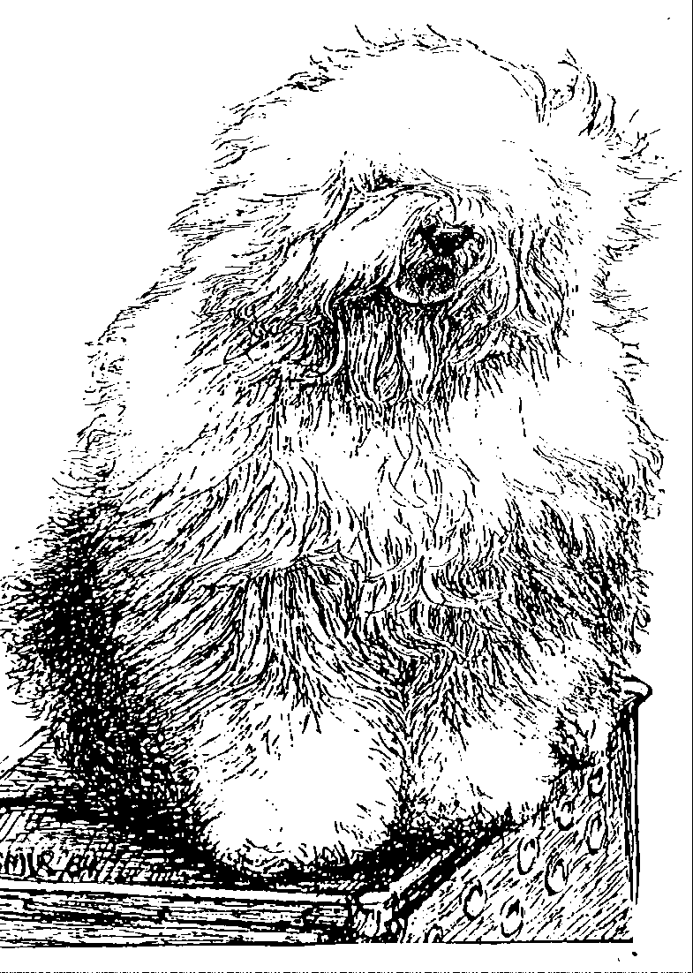
“BRWYN” BRWYN’S WHO WANTS TO LIVE FOREVER
“Macy”
ouders | grootouders | (O)grootouders | (OO)grootouders | (OOO)grootouders
 |  |  | V. Weatherproof | V. Barnolby Lord Shavley
 |  | V. Barnolby Troubleshooter | of Barnolby | M. Janmay of Kenstaff
 | V. Souvenir | at Oldoak | M. Barnolby | V. Ginnsdale Stargazer Blue of Barnolby
 | van Kehr Fully Maid |  | Wedding Bells | M. Barnolby White Bear
 |  |  | V. Sparkle Square’s | V. Jolly Joggler’s Star Light
 |  | M. Silver Mystery’s | Carte Blanche | M. Barking Bear’s Dorenthy Delightful
 |  | Josje’s Prime Time | M. Silver Mystery’s | V. Barking’s Bear’s Davy Belle
V. Saphir |  |  | Hoyden Hazel | M.Vigilat’s Unique Surprise
Kehr Fully Maid |  |  | V. Jolly Joggler’s | V. Pockethall Prince William
 |  | V. Sparkle Square’s | Star Light | M. Donnibobs Wot A Picture
 |  | Carte Blanche | M. Barking Bear’s | V. Shaggy Bear’s Sugar Foot Stomp
 | M. Paddy Paddington |  | Dorenthy Delightful | M. Amble Gait’s Arrabelle Blue
 | is Kehr Fully Maid |  | V. Barking Bear’s | V. Pockethall Prince William
 |  | M. Trademark’s | Evergreen my Beatle | M. Amble Gait’s Arrabelle Blue
 |  | Sparkle Square Sophie | M. Blueville | V. Shapod Special Surprise
 |  |  | Ain’t she Cute | M. Baucott Blue Delft
 |  |  | V. Barnolby | V. Ginnsdale Stargazer Blue of Barnolby
 |  | V. Weatherproof | Lord Shavley | M. Sincerity of Barnolby
 |  | of Barnolby | M. Janmay | V. Grancoats Blue Venture
 | V. Barnolby Troubleshooter |  | of Kenstaff | M. Audrey’s Delight
 | at Oldoak |  | V. Ginnsdale Stargazer | V. Jason Marcos Ginn Junior
 |  | M. Barnolby | Blue of Barnolby | M. Saucy Paw Sheba
 |  | Wedding Bells | M. Barnolby | V. Aberfells Georgey Porgy
M. Kadootje |  |  | White Bear | M. Barnolby Wendy Bruin
van Kehr Fully Maid |  |  | V. Jolly Joggler’s | V. Pockethall Prince William
 |  | V. Sparkle Square’s | Star Light | M. Donnibobs Wot A Picture
 |  | Carte Blanche | M. Barking Bear’s | V. Shaggy Bear’s Sugar Foot Stomp
 | M. Silver Mystery’s |  | Dorenthy Delightful | M. Amble Gait’s Arrabelle Blue
 | Josje’s Prime Time |  | V. Barking Bear’s | V. Shaggy Bear’s Sugar Foot Stomp
 |  | M. Silver Mystery’s | Davy Belle | M. Amble Gait’s Arrabelle Blue
 |  | Hoyden’s Hazel | M. Vigilat’s | V. Reeuwijk’s Dear Tom Tod
 |  |  | Unique Surprise | M. Reeuwijk’s Fabulous Lady

